< CSE211 Web Programming, Fall Semester 24/25>

<Assignment #1: Websites conceptual Design and mock-up>

<222100333, Elaf Wael Hamdy Elsaeed>

**2.3.1: Research:**

**Web evolution from Web 2.0 to Web 4.0**

**1- The defining characteristics of Web 2.0 to Web 4.0.**

* The evolution from Web 2.0 to Web 4.0 shows the changes in the interaction between users and the internet and how data is processed.
* The internet, originally created in 1990 by Tim Berners-Lee [1], has undergone significant evolution, with each web version introducing new characteristics

**1. Web 2.0 (participative Web)**:

* **User- generated content:** focus on content creation by users (blogs

social media).

* **Social Networking: social** interactions (Facebook, Twitter) [2].
* **Interactivity:** enhancing user engagement by letting them be able to like, share and comment.
* **Collaboration:** Tools for collective collaboration (Wikipedia, Google Docs).

**2.Web 3.0 (Semantic Web)**:

* **Semantic Web:** enable users interacting with artificial intelligence.
* **Decentralization**: Shift towards decentralized networks (blockchain technology) [3].
* **Emphasizes personal data ownership.**
* **Personalization:** based on user data and preferences.

**3.Web 4.0 (Symbiotic Web)**:

* **Intelligent Web: trying** to make more autonomous systems.
* **Emotionally Intelligent interfaces:** it made the system able to understand and respond to human emotions.
* **Self-Sovereign Identity:** Users have control over their digital identities and data.

**2- What are the key features of Web 2.0 and how does it empower the power of networks?**

**The key features of Web 2.0 include [3]:**

* **Folksonomy:** classification of information, which allows users to categorize and label content “tagging.”
* **Rich user experience: its** interactive and engaging interfaces to users, which the input is responsive to the user action (dynamic content)
* **User-generated Content:** enhanced collaboration and creating videos, blogs, and social media posts.
* **Collaboration Tools:** enable real time collaboration (e.g., Google docs).
* **Social Networking: enable** interaction between users such as Facebook
* **Software as a service (SaaS)**

**Empowering the Power of Networks [4]:**

* **Collective intelligence:** made users able to collect more information and increase their knowledge leads to richer content (e.g., Wikipedia)
* **Network effects:** increased the ability to engage and join which increased the value of the platform such as social media platforms.
* **Enhanced communication: Real-time** communication tools such as chat apps
* **Empowerment of Individuals**: where users were able to share their opinions.

Web 2.0 is a participative Web and social Web. It emphasizes user-generated content, ease of use and participatory culture.

**3- What are the key features of Web 3.0 and how does it empower the power of networks?**

**Key Features of Web 3.0:**

* **Semantic Understanding: machines can understand the meaning of data because it is structured.**
* **Decentralization**: it is using blockchain technology.
* **Artificial Intelligence and Machine Learning**: they are used to understand data and based on making decisions and customizing the user experiences. It learns and improves the system over time.
* **Personalization:** by learning the user interactions and behavior it was able to personalize it.
* **Smart Contracts: Automated** contracts that execute when predetermined conditions are met.

### **Empowering Data and Knowledge Connections**

* **Collaboration and Sharing: made** it easier to share and organize information.
* **Data Ownership and Privacy [5]:**it provides user control on his data, this promotes trust.
* **Dynamic and Adaptive Systems: based** on the user interactions it learns which makes it more personalized.
* **Enhanced Data Interoperability: By** standardizing data formats and enabling systems to understand relationships between different data sets.

Web 3.0 will be driven by technology to enhance user interacting with artificial intelligence

**4- What are the key features of Web 4.0 and how does it empower intelligence connections?**

**Key Features of Web 4.0:**

* **Artificial Intelligence and Machine Learning: systems are smarter and learn from interactions.**
* **Emotional and Social Intelligence:** made the system able to understand human emotions then gave the user more personalized interactions [6].
* **Autonomous Agents:** It is an intelligent agent that makes decisions based on learning and it performs tasks independently.
* **Virtual Reality:** provide richer interactions to users.

### **Empowering Intelligent Connections**

* **Contextual Awareness:** advanced AI is understanding user interactions, text and preferences which lead to make it more relevant and helpful for the user
* **Real-time Decision Making:** data is being analyzed and trends are being followed by autonomous agent to enhance user experience
* **Emotional Engagement:** user emotions can be recognized and responded to which improve user interaction and engagement.
* **Trust and Security: decentralized** technologies made a more secure environment for interactions and enabled users to trust the system.

Its symbiotic contact between man and machine.

**5- The importance of collective intelligence, social networking, social media, and social bookmarking:**

Collective intelligence, social networking, social media, and social bookmarking play significant roles in today's digital landscape [7].

* **Collective Intelligence:** its shared or group intelligence that is created from team working, collaborations and sometimes from competition of individuals. It helps to see a wide range of knowledge, leading to more creative, out of the box solutions that help in decision making.
* **Social Networking:** these networks help users to share information, interests and collaborate. By sharing interests, it can build communities based on it and it leads to improved innovation and productivity.
* **Social media: it** includes a wide range of online platforms that help to share, create, and react with content which helps to know more about each other and learn more and it helps a lot in building community.
* **Social Bookmarking:** it allows users to save, organize, and make it easier to share web resources and find relevant data easier. Social bookmarking can enhance employee innovation.

**6- How these technologies empower the current and future business plans.**

The relation between collective intelligence, social networking, social media, and social bookmarking into business strategies it helps

* **Collective Intelligence: helps** solve complex problems and make out of the box solutions [8].
* **Social Networking: using** platforms such as Facebook and linked in, help strengthening relationships and expanding professional networks.
* **Social media: using** platforms for marketing make the customer engagement increases, which increases the awareness and loyalty
* **Social Bookmarking:** service like Pinterest help to inspiration business establishing thought leadership

**7- How do you intend to use the latest technologies in your profession?**

Integrating emerging technologies into professional practice can significantly enhance efficiency, innovation, and competitiveness:

* **Artificial Intelligence (AI) and Machine Learning:** AI helps to analyze large datasets, help in decision-making and predictive modeling. AI can automate routine tasks, allowing professionals to focus on more complex responsibilities [9].
* **Internet of Things (IoT):** uses IoT devices to monitor and manage operations in real-time, improving operational efficiency and reducing downtime.
* **Blockchain Technology:** Adopt blockchain for secure and transparent transactions, enhancing trust and reducing fraud. This is particularly beneficial in supply chain management, where blockchain can provide end-to-end visibility [10].
* **5G Connectivity:** Adopt 5G technology to enable faster and more reliable communication
* **Cloud Computing:** cloud services for scalable storage and computing power, enabling remote collaboration and access to resources. Cloud platforms can also support the deployment of AI and IoT applications.

**2.3.2: Website Planning.**

1. **Define the purpose of your intended website:**  
   It's a pet website called "Paws and Tails", The target of "Paws and Tails" is to serve as a resource for pet owners and people who are interested in pets. It offers services like pet adoption, donations, a pet hotel, hospital, care tips, feeding guides, breed information, a training academy, some unique features like pet marriage, guidelines for how to take care of your pet and latest news.,
2. **What would you like the website to accomplish?**  
   The website's goal is to be a one-stop solution for all pet-related needs. It will help pets find new homes ,help everyone know more about any the breed and be able to choose what breed to marry ,make every able to donate, and buy stuff for the pet , the most important goals the hospital ,guidelines and latest news because it will help pet owners to take care of their pets specially when there is a spreading virus; because I just lost my cat because I didn't know that there was a new virus that I should vaccinate my cat from .
3. **Who is your intended audience?**

* Pet owners and pet shop owners.
* People that are curious about pets.
* People who are planning to adopt or buy (toys and food).
* People looking for services like pet hospitals, hotels, and training academies.

1. **What opportunities, problems, or issues does your planned website address?**

**Opportunities**: Helping pets find new homes through adoption, providing comprehensive pet care information, and offering services like hospitals and hotels in one place.

**Problems**: that there are no available websites that have all in one and some features are not even available.

**Issues**: Ensuring accurate and trusted information about pets, pet care and each breed's specific needs, making it quickly and easy to address the user's needs.

1. **What kind of content could be incorporated on your website?**The website will include:

* Articles and guides on pet care, feeding, and training.
* Information on your breed with their characteristics and care tips.
* Video tutorials and guides on how to train your pet and take care of it.
* Online forms for adoption, donations, booking hotels and hospital visits.
* Interactive tools like breed matching quizzes

1. **How will the site serve the client?**  
   "Paws and Tails" will serve the client by giving them access to wide range of pet related services, such as:

1.Finding and adopting pets.

2.Booking pet hotel stays and hospital appointments.

3.Accessing expert information on pet care, feeding, and training.

4.Supporting donations to shelters and other pet-related causes.

1. **What is the best method for the user to do what he wants?**

To choose what they want from the navigation bar that will be well-organized so users can find the services and information quickly Interactive features like buttons for "Adopt," "Donate," and "Book a Service" will guide users to their desired action.

1. **How will users find the function?**  
   Users will find distinct functions (adoption, hotel booking, pet care….) through: A clear main menu with categories such as "Adoption," "Pet Care," "Donate," and "Services."
2. **How will the results of the function be received?**

The adoption applications or booking service will be sent to the site’s administrators and the relevant service providers (hotel, hospital ....) Users will receive confirmation emails or messages, and the admin team will process the requests.

1. **What will the receiver do with the received entries?**  
   Upon receiving entries from adoption forms or service bookings, the website administrator will review each submission for completeness and accuracy, then forward it to the appropriate department—such as the adoption team, hotel, or hospital staff—for further processing and follow-up with the user.
2. **How will the receiver deal with results?**After receiving the entries, the website admin will:

* Contact users for follow-up on their applications (adoption, hotel booking, etc.).
* Process the entries, whether it is scheduling an adoption meeting, confirming a hotel reservation, or updating donation records.
* Provide further instructions or information to users as needed.

1. **What follow-up will be needed?**Follow-ups may include:

* Confirmation emails for bookings and donations.
* Updates on adoption applications (approval, next steps, etc.).
* Tracking the orders
* Keep on eye on the medical record

1. **List at least two related or related sites found on the web. Explain why you chose them:**

* **Petfinder.com**: because it provides adoption services and gives some information about the pet. ([Urgent Need for Pet Adoption - Find Dogs & Cats & More | Petfinder](https://www.petfinder.com/))
* **Rover.com**: connects pet owners with services like pet sitting, boarding, and walking.(<https://www.rover.com/> )
* **petsmart.com:** This site offers a variety of pet-related services and products, including adoption services, pet hotels, grooming, and training, which aligns closely with the services.([Pet Supplies, Accessories, and Pet Food - Pet Stores | PetSmart](https://www.petsmart.com/))
* **PetCareEG.com:** veterinary services, hotel, and academy.([Pet Care Hospital – Pet Care Hospital New Cairo](https://www.petcareeg.com/))

1. **Prepare the Planning Analysis Sheet:**

**a. Website Goal:**  
To establish "Paws and Tails" as a comprehensive platform offering pet adoption services, care guidance, educational resources, and pet-related products, catering to pet owners, enthusiasts, and prospective adopters.

**b. List the working titles of seven to eleven pages on your website, excluding the homepage:**

1. news
2. Academy
3. New family
4. Hospital
5. Hotel
6. Buy
7. Donation
8. About Us

**c. Describe the contents (facts, text, pictures, audio, video, user inputs, etc.) of each page, including the homepage:**

* **Homepage:** image featuring pets, navigation bar with links to all major sections, footer with all the information to contact, featured services (hotel, hospital, and Academy), and about us.
* **New family:**2 images related to starting a new family, this page offers starting new by (Adopting or by pets mating), navigation bar with links to all major sections, footer with all the information to contact.
* **Donation:** Information on what the users can donate (e.g., clothes, food, money, and toys) an online form for donations, images to help donations., navigation bar with links to all major sections, footer with all the information to contact.
* **Pet Hotel:** takes Information from the hotel guest (e.g., name, age,) booking form, images of hotel cat and dog. Navigation bar with links to all major sections, footer with all the information to contact.
* **Pet Hospital:** medical information, 3 images of cats that explain the service, navigation bar with links to all major sections, footer with all the information to contact.
* **Academy**: booking form for training classes which takes the pet (name, Type, start date), image of women playing with her dog, navigation bar with links to all major sections, footer with all the information to contact. navigation bar with links to all major sections, footer with all the information to contact.
* **News: Pet** Care Tips, Articles, guides, at last news, 2 images one of a sleeping dog and the second of a woman feeding a cat. Navigation bar with links to all major sections, footer with all the information to contact.
* **About us:** that gave you some details about the website
* **Buy**: Gave you the ability to buy from it (veterinary pharmacy, litter boxes, toys, food, furniture, clothes and carries & crates) and have an image of the store.

**d. Describe how users will use forms to collect information:**

* Donation Form: Users will provide their name and what item they want to donate
* Hotel/Training Booking Form: Users will input their pet’s details, dates, and services needed.
* Adoption and mating form: Users will fill out details like their name, address, the pet they are interested in, and their experience with pets.

**e. Storyboard (organization):**

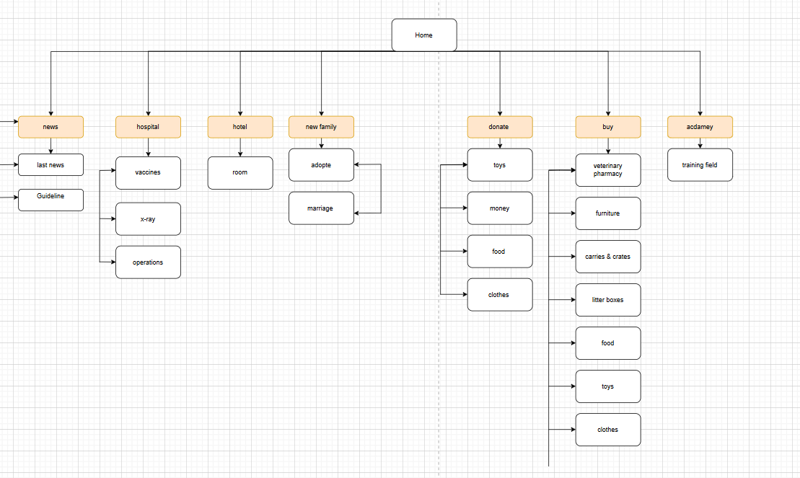

**f. Create a wireframe for each page of your website:**

**1. Homepage:**

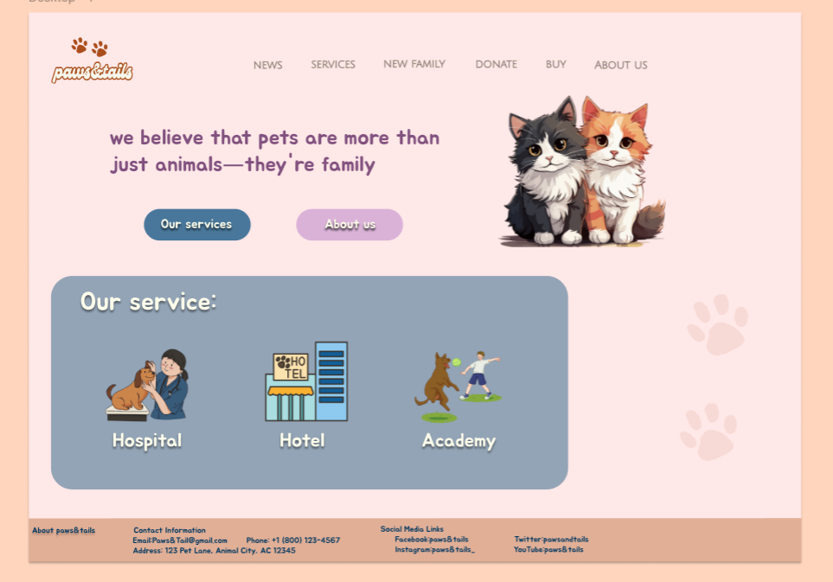

**2.About us:**

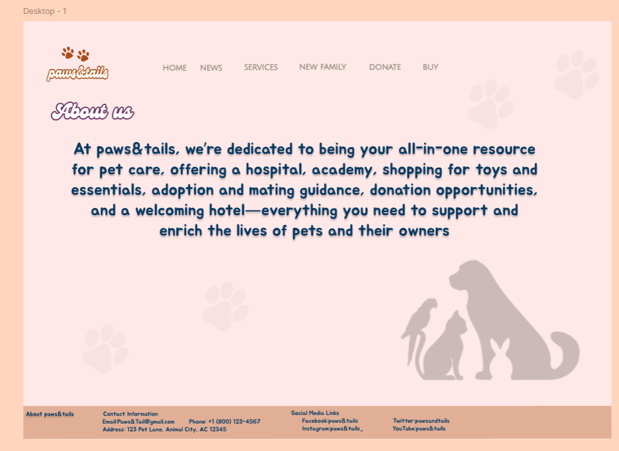

3**.news and guideline**

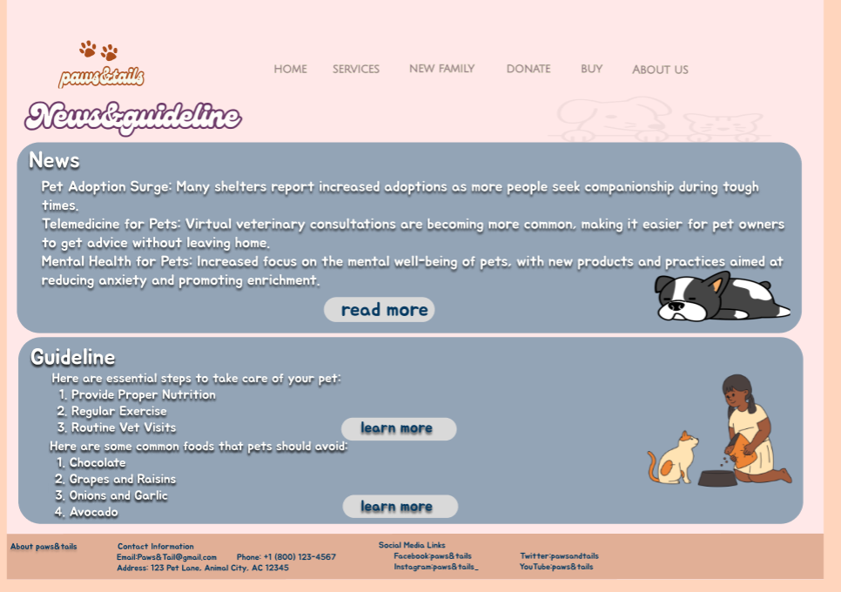

**4. New family:**

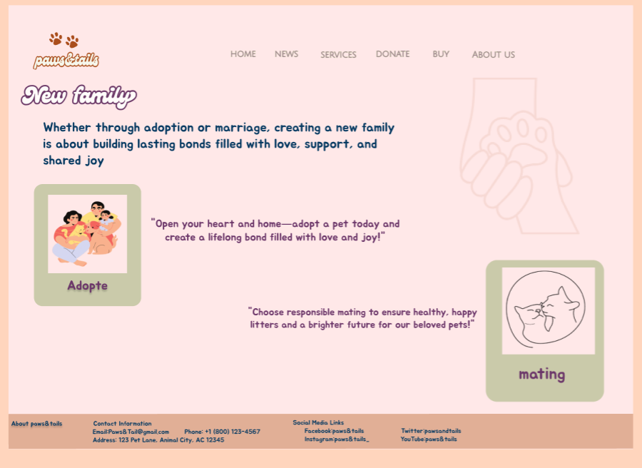

**5. Academy services :**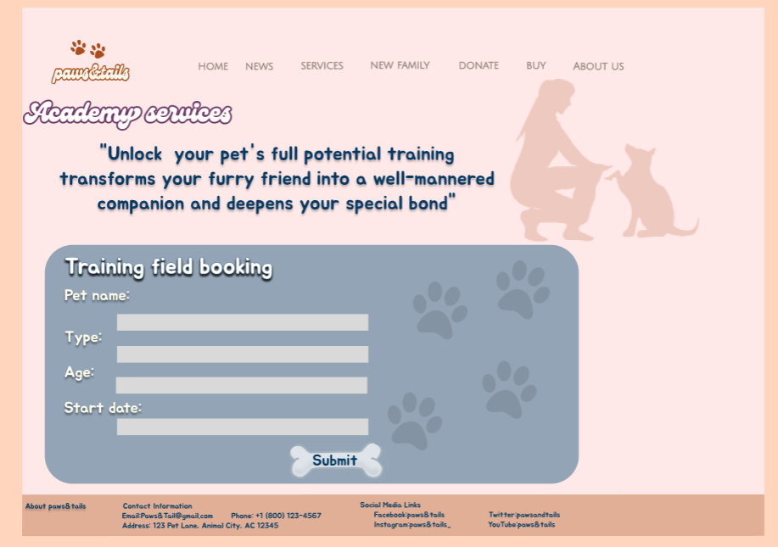

**6. Hospital:**

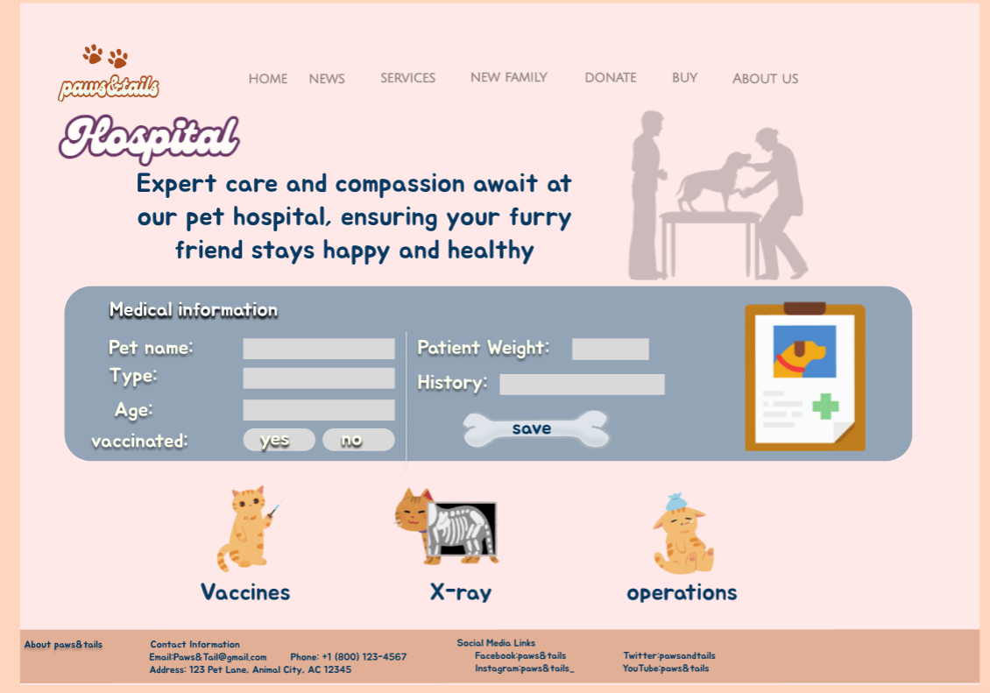

**7.Hotel:**

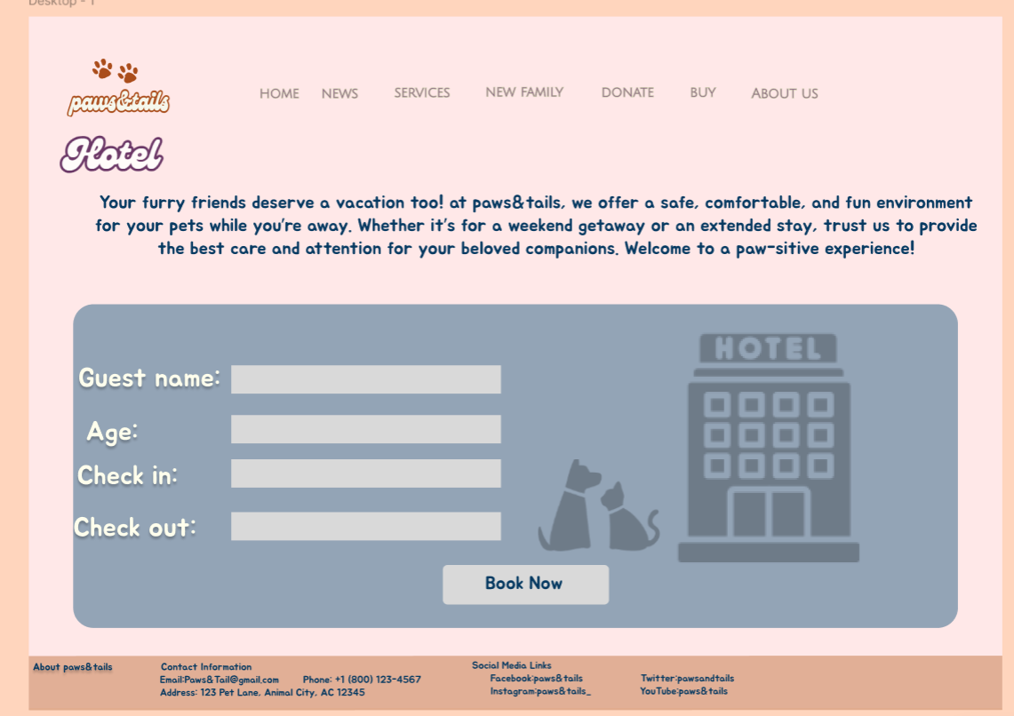

**8.Buy:**

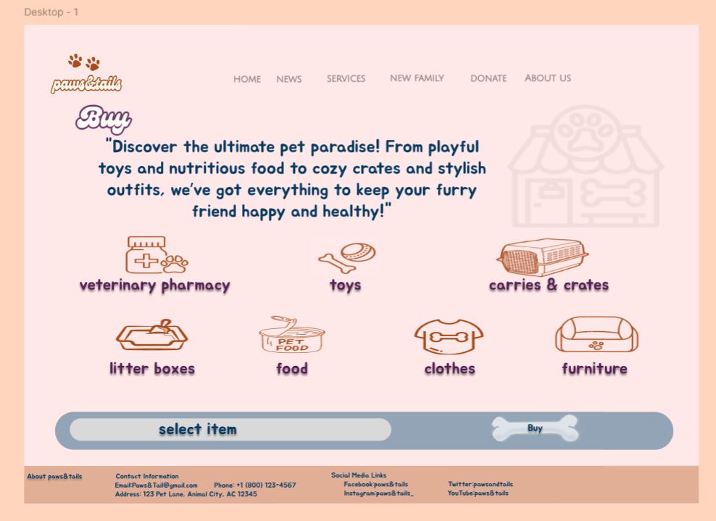

**9. Donate:**

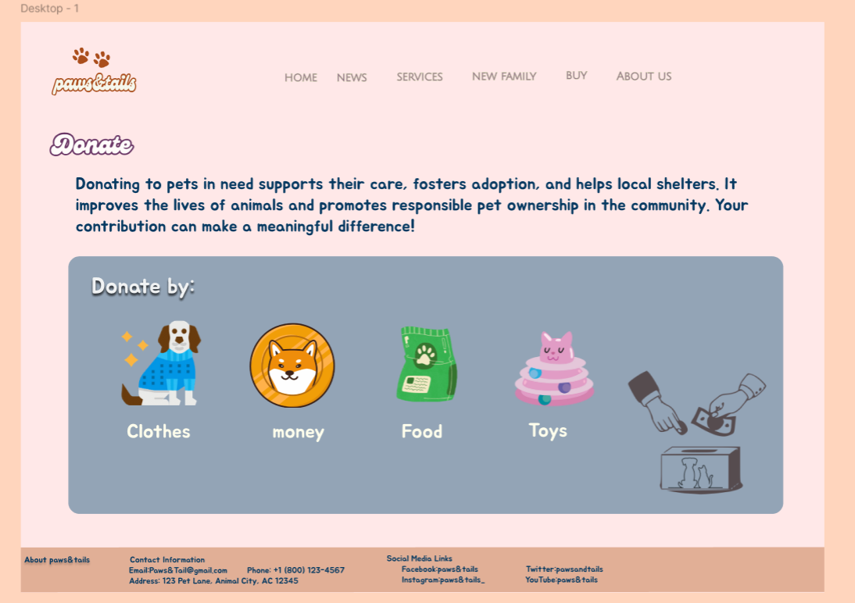

**2.3.3: Website Design.**

**[A]:**

1. **Law of Prägnanz (Simplicity):** Simplify layouts across all pages for easy navigation and understanding. A clean, minimal approach allows users to find essential information quickly. Each page will focus on core functions without unnecessary elements.
2. **Closure:** Group pet profiles within bordered or cohesive sections, visually uniting details like images, descriptions, and action buttons. This helps users quickly associate these elements as one entity. Profiles will feel complete, even if borders are not fully closed.
3. **Symmetry and Order:** Structure each page with a balanced, organized layout to communicate information quickly. Consistent alignment and balanced spacing create a professional, user-friendly experience. This symmetry helps users locate information effortlessly.
4. **Figure/Ground (Contrast):** Use white space around important content to create contrast and draw attention to key elements. This separation ensures content stands out from the background, enhancing readability. Key sections will feel distinct and easy to scan.
5. **Uniform Connectedness: Visually** group related elements, like images, titles, and action buttons, within shared backgrounds or containers. This reinforces that they function together. Users will instinctively recognize these grouped elements as part of the same purpose.
6. **Common Region:** Space related content in shared regions using containers or background colors to reinforce their connection. For example, grouping all services within a single section establishes unity. Users can instantly identify connected categories.
7. **Proximity: Place** related elements, such as text and associated buttons, close together to convey relationships. Space between distinct groups ensures easy scanning. Proximity helps users quickly understand which items belong together.
8. **Continuation:** Design page layouts that flow naturally to guide users’ eyes across sections. For instance, horizontal scrolling for services encourages further exploration. This continuous flow promotes smooth navigation across content.
9. **Common Fate (Synchrony):** Synchronized elements, like carousels or scrolling testimonials, change together to reinforce their connection. This technique helps users perceive these items as related. It is especially useful for engaging interactive content.
10. **Parallelism:** Use parallel rows and columns for listings to establish visual order and make items easy to scan. Parallel alignment conveys that the items share a similar role. This approach works well for pet or service listings.
11. **Similarity:** Maintain consistent button styles, colors, and sizes across pages to establish a unified look. Similarity in design helps users identify interactive elements. They will recognize buttons and icons by familiar characteristics.
12. **Experience:** Apply familiar layouts like a top navigation bar and bottom footer, which users expect and know how to use. This meets users’ past experiences with website structures. Familiarity promotes ease of navigation and reduces the learning curve.

**[B] Deployment:**

1. 1440 X 1024

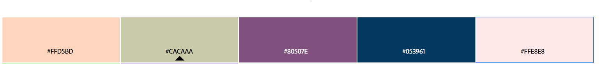

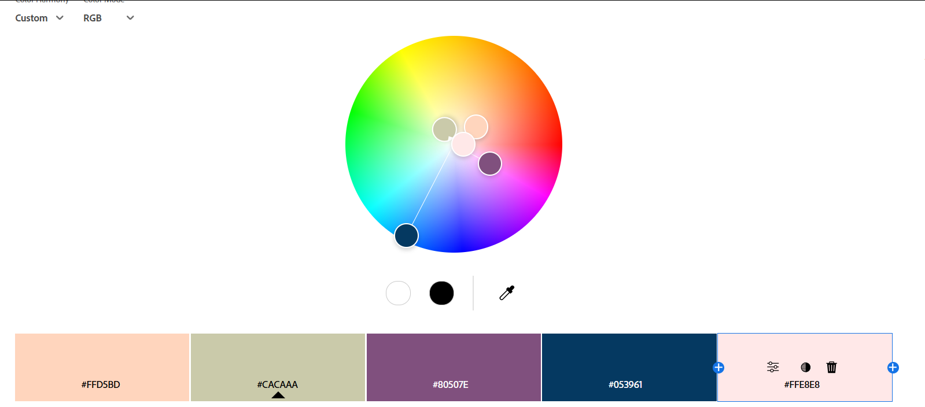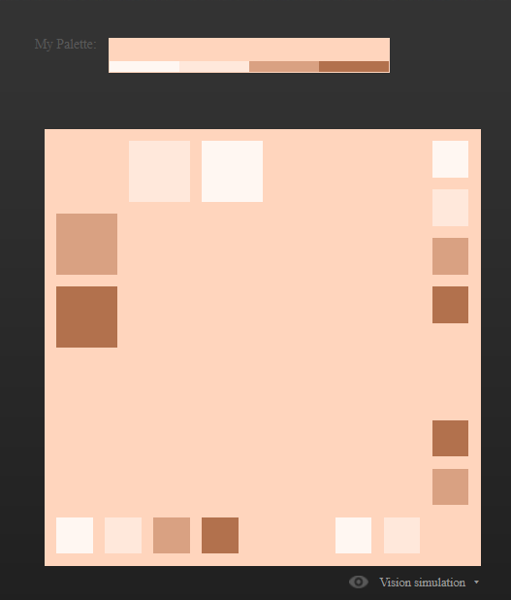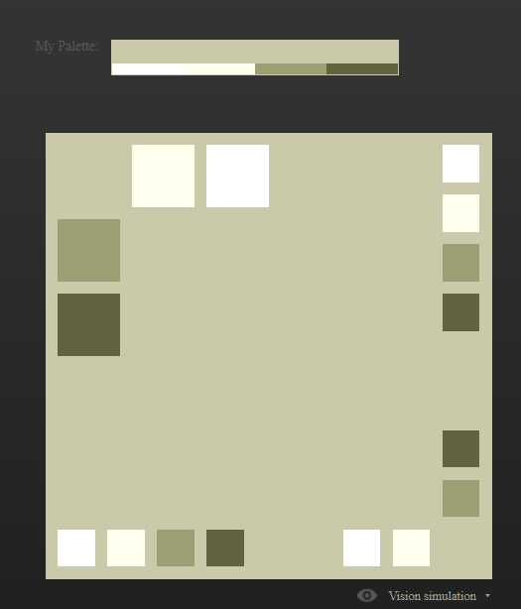

 

3.

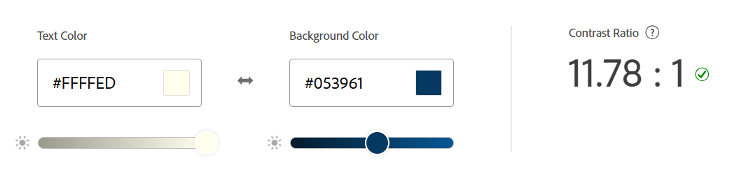

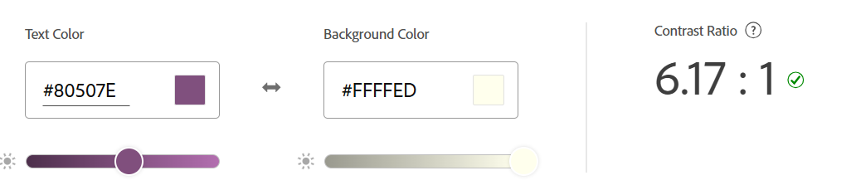

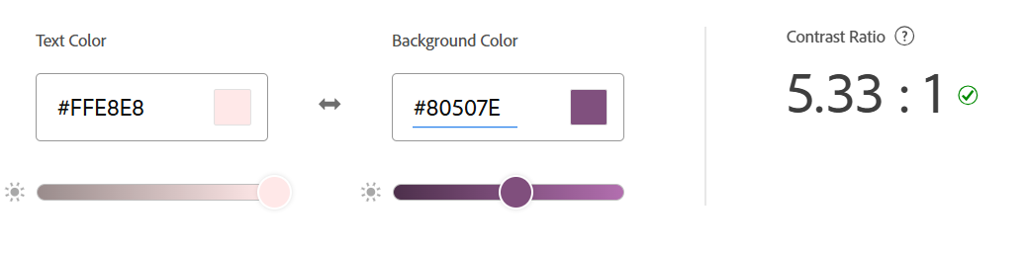

**4.Front-End Development Technologies:**

* **HTML5/CSS3**: These technologies are fundamental for structuring and styling web content, enabling responsive designs that adapt seamlessly to various screen sizes. Their importance in modern web development is well-documented.
* **JavaScript**: JavaScript enhances user experience by adding interactivity, such as animations, dynamic content loading, and interactive maps. Its role in creating dynamic web applications is extensively covered [11].

**5.Content Management Systems (CMS):**

* **WordPress**: Ideal for smaller-scale, quick-to-deploy websites, WordPress offers numerous tourism-focused plugins for maps, booking, and galleries, facilitating efficient content management. The use of CMS platforms like WordPress in web development is discussed in numerous studies.

**6.Back-End Development Technologies:**

* **PHP**: A widely used server-side scripting language, PHP is suitable for developing dynamic web pages and applications. Its performance in web development is compared with other technologies [12].
* **MySQL**: MySQL is effective, especially when managing data relationships. Its application in web development is analyzed in numerous studies.

**7.Metrics for Measuring Website Success:**

1. **User Engagement:**
   * **Page Views**: Monitoring the number of times pages are accessed helps identify popular content.
   * **Average Session Duration**: Understanding how long users spend on the site indicates engagement levels.
   * **Bounce Rate**: Tracking how often visitors leave without interacting can highlight issues with content or user flow.
2. **User Interaction:**
   * **Click-Through Rate (CTR) on Booking Links**: Measuring how often users proceed to booking platforms serves as a key success indicator.
   * **Conversion Rate**: Tracking the percentage of users who complete desired actions, such as booking or subscribing to a newsletter, is crucial.
   * **Content Popularity**:
     + **Most Viewed Pages**: Identifying which tourist sites or content sections receive the most attention.
     + **Social Shares**: Tracking how often pages or images are shared indicates user interest and social reach.
3. **User Feedback:**
   * **Review Ratings and Comments**: User reviews can reveal satisfaction levels and areas for improvement.
   * **Net Promoter Score (NPS)**: Gauging overall user satisfaction and likelihood to recommend.
4. **Technical Performance:**
   * **Page Load Time**: Ensuring fast loading speeds is especially critical for a multimedia-rich site.
   * **Mobile vs. Desktop Use**: Insights on device usage can inform mobile responsiveness improvements.
   * **Error Rate**: Monitoring broken links, failed requests, and other errors to improve the user experience.

**8.Html structure code for every page:**

**1.HomePage:**

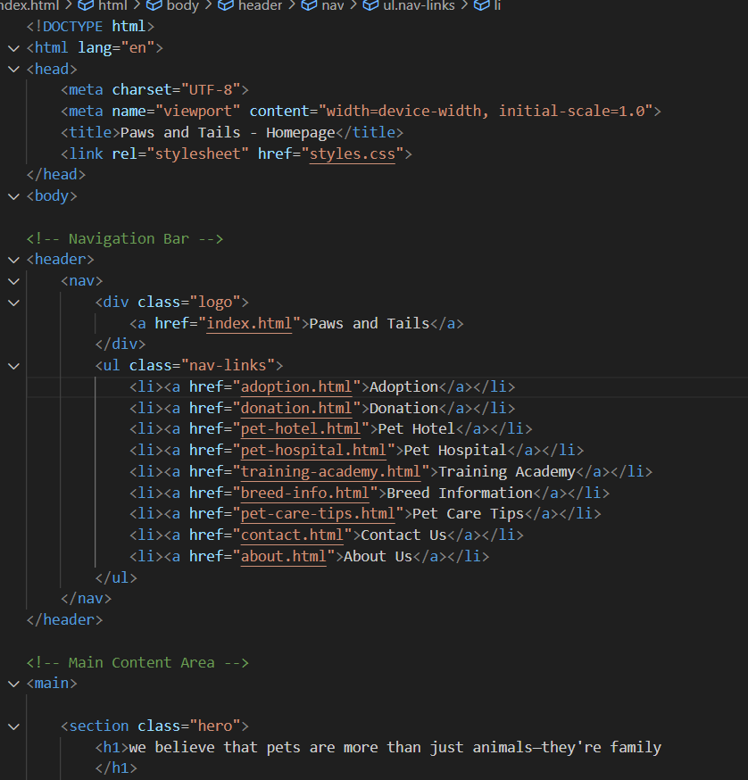

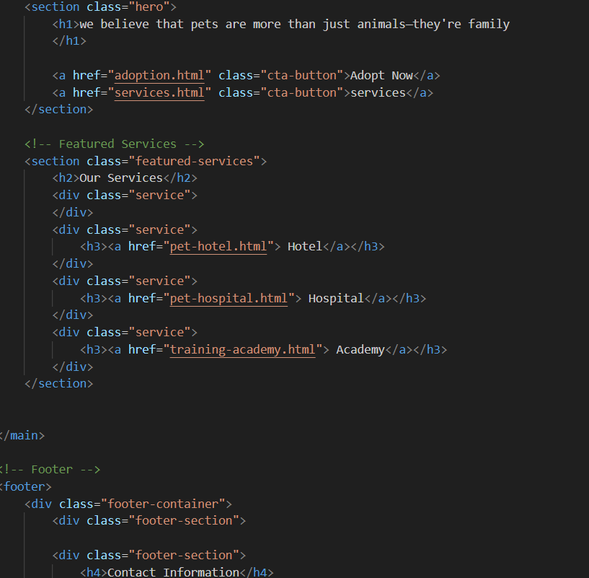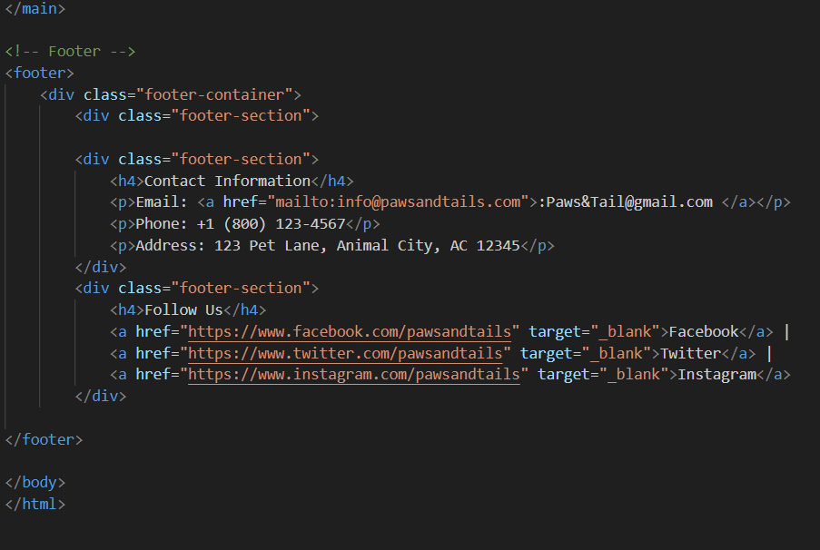

**2.About us:**

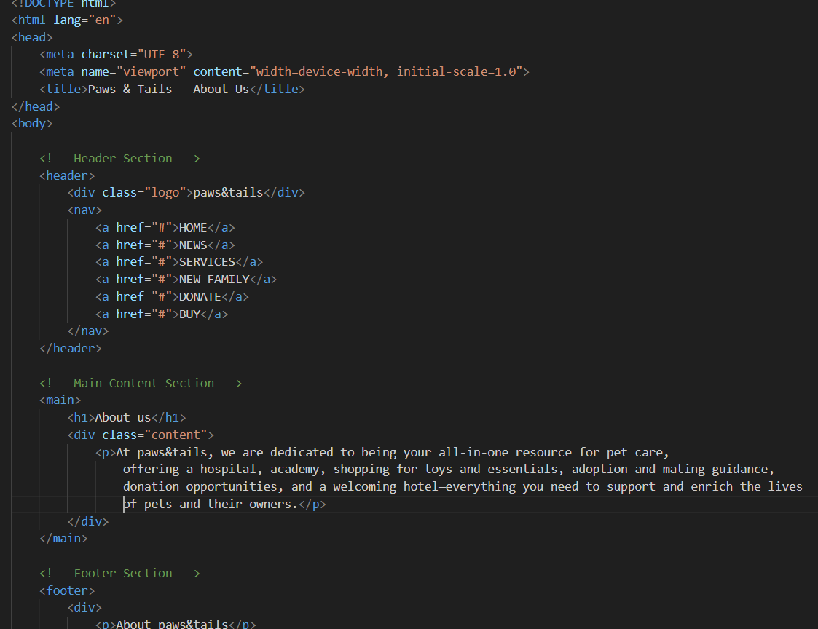

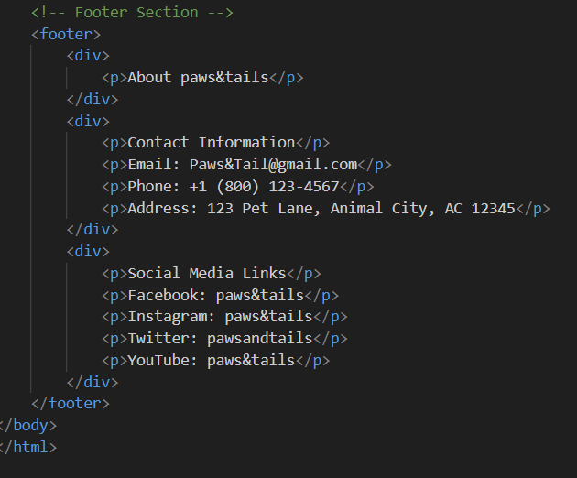

**3.news and guideline:**

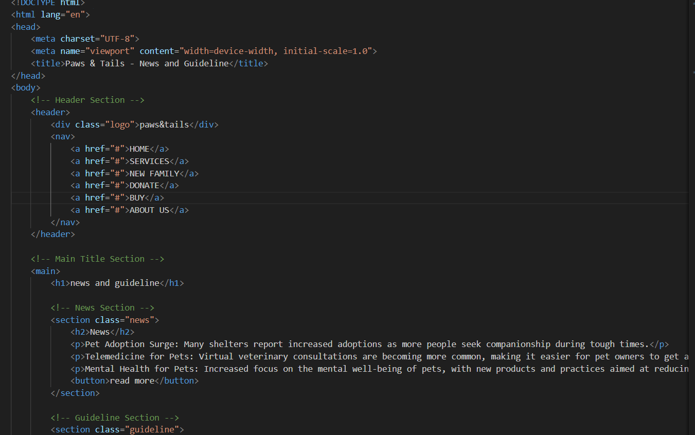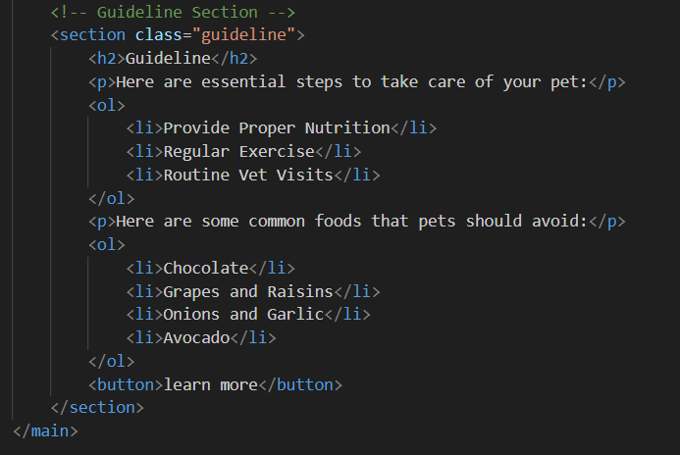

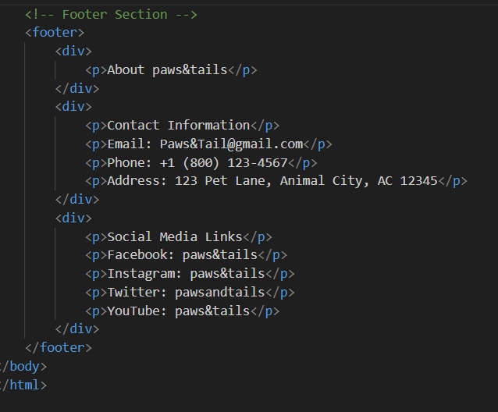

**4. New family:**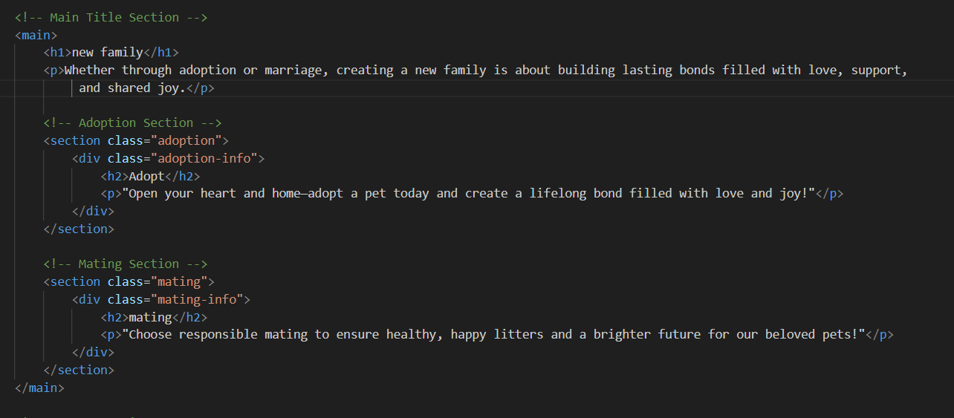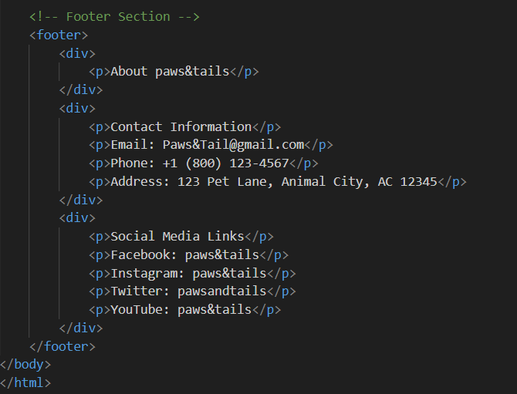

**5. Academy services :**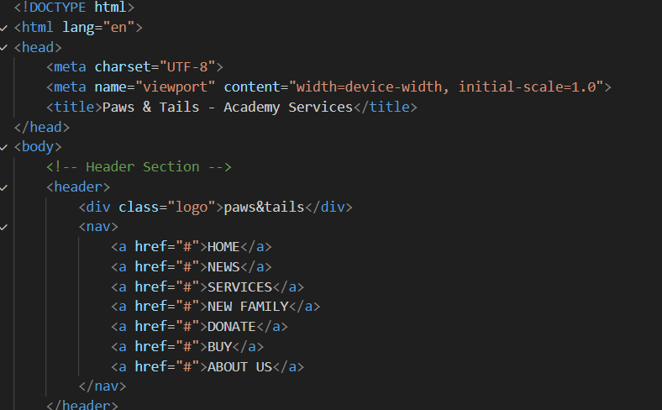

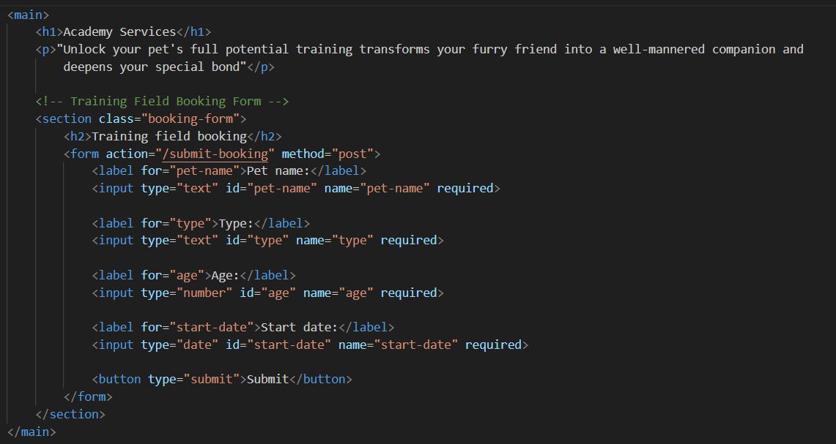

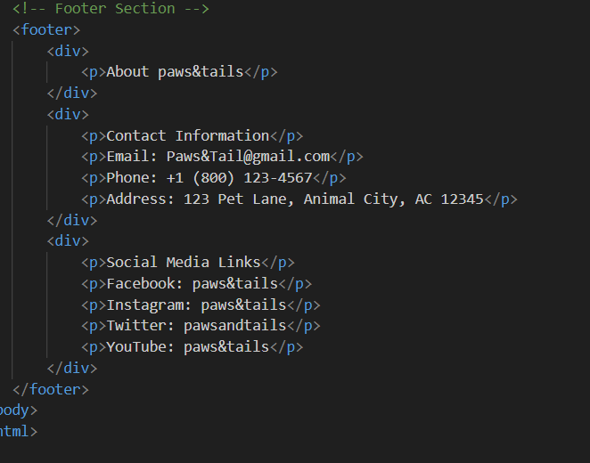

**6. Hospital:**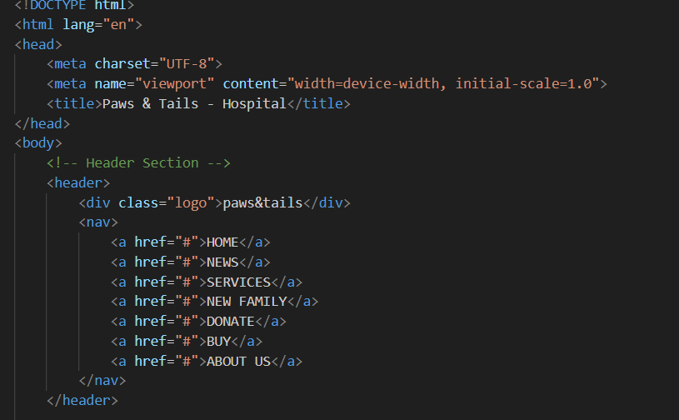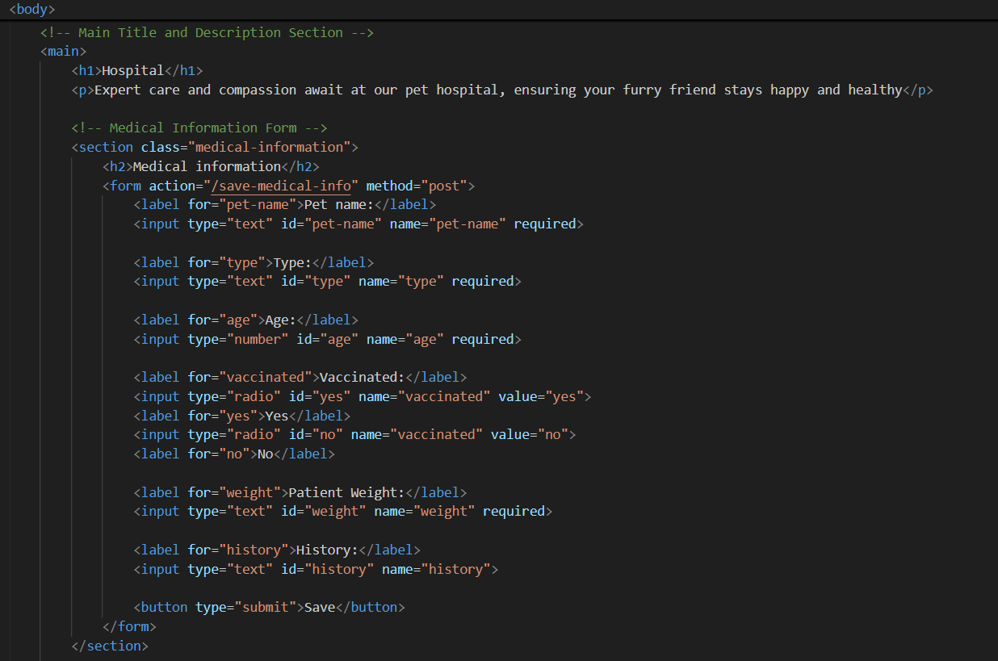

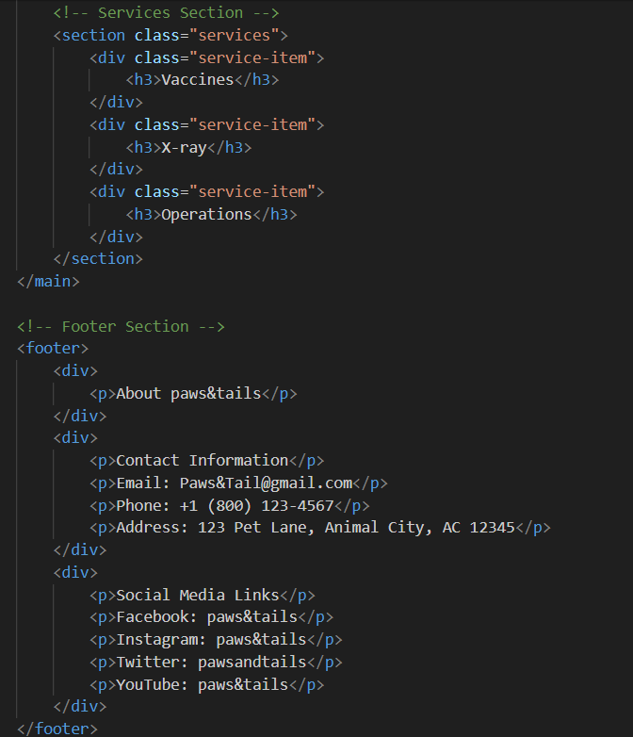

**7.Hotel:** 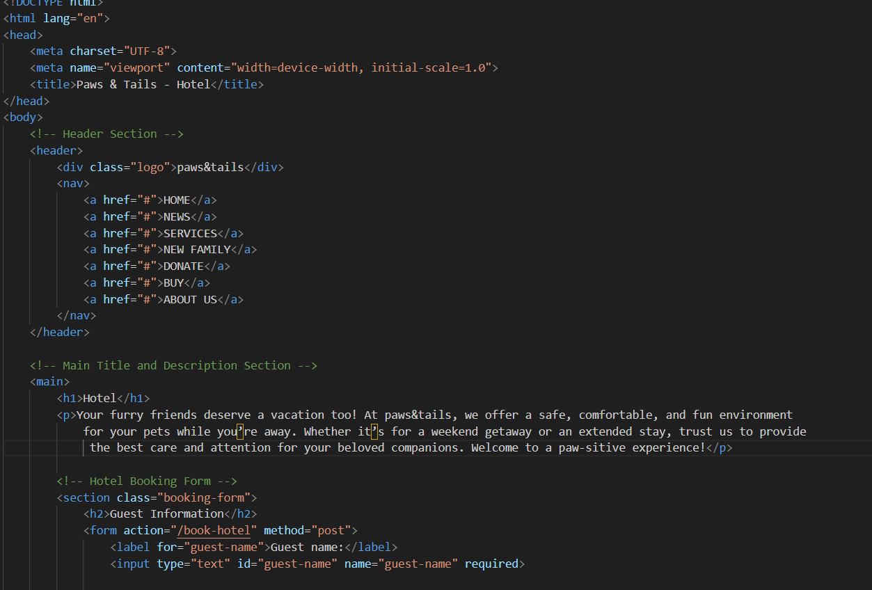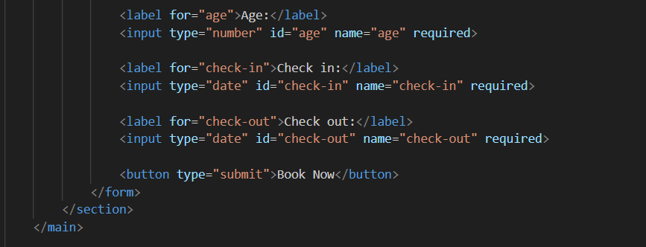

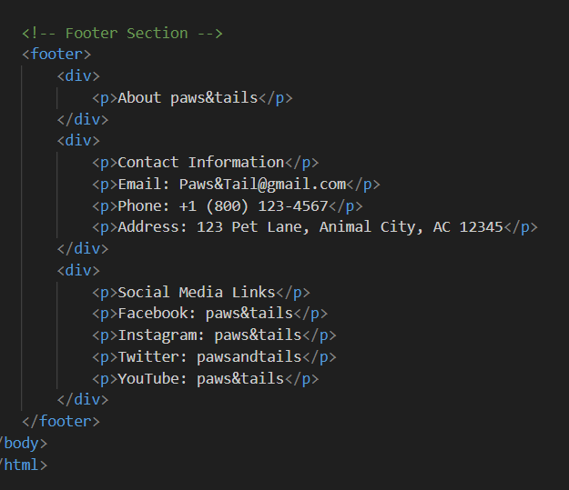

**8.Buy:**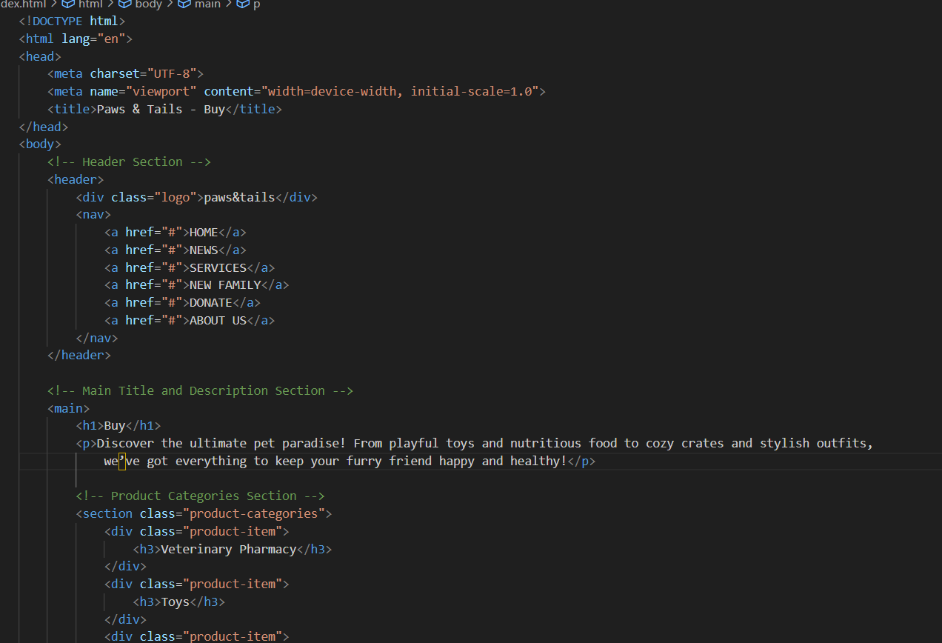

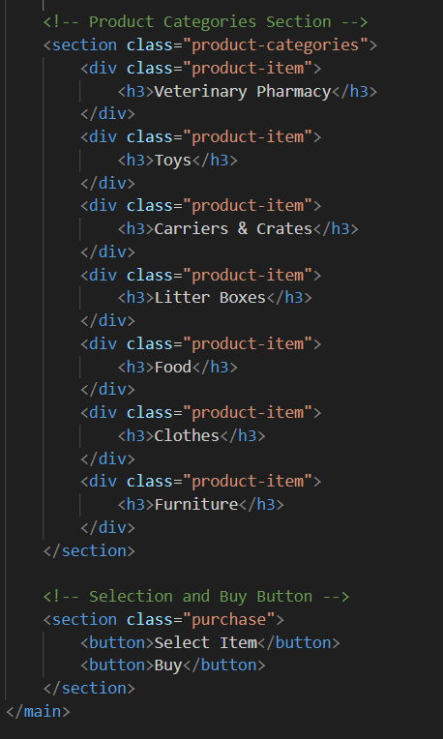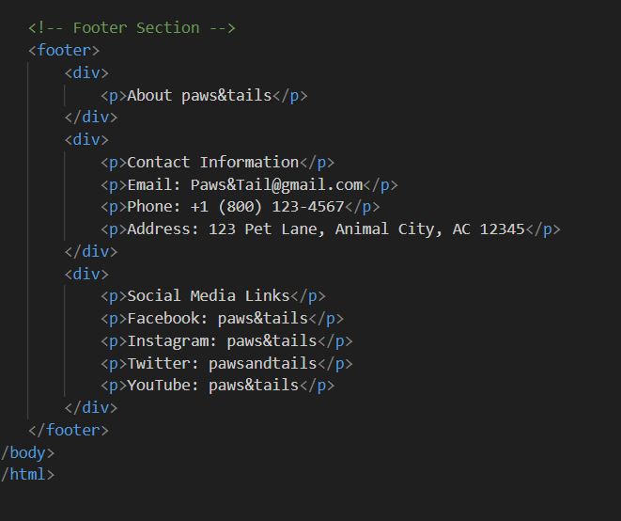

**9. Donate:**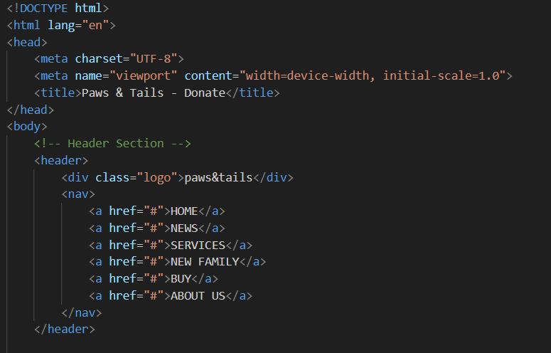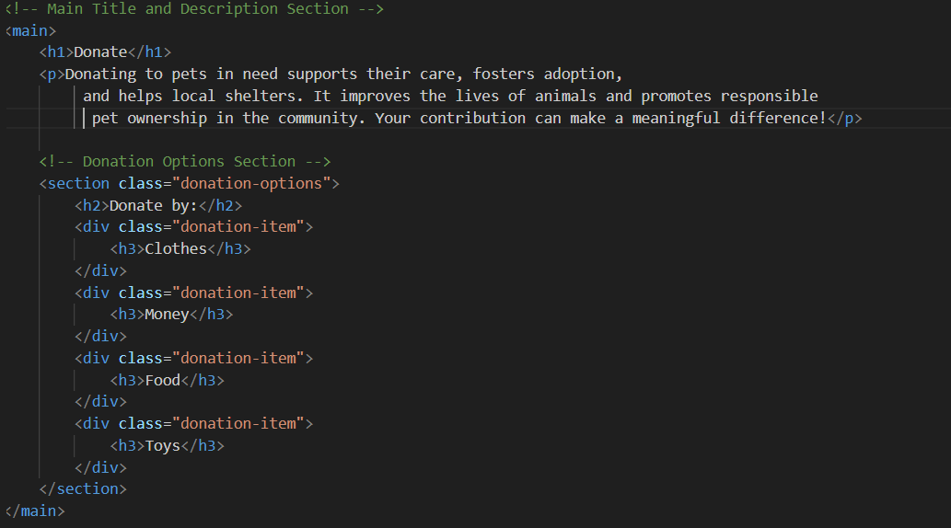

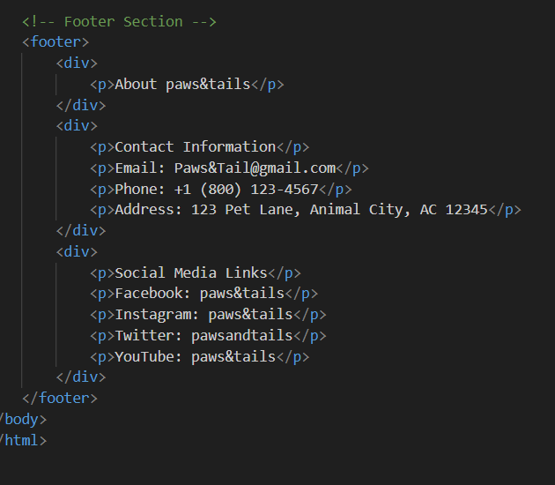

# **Plagiarism:**

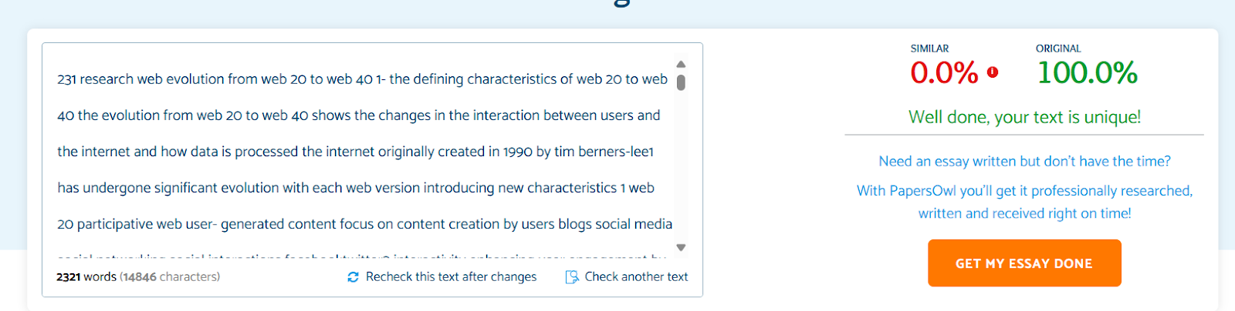

**Reference:**

[1] N. Willing, “What is Web 2.0? - Definition from Techopedia,” *Techopedia.com*, 2019. <https://www.techopedia.com/definition/4922/web-20>

[2] W. Hosch, “Web 2.0 | Definition & Examples | Britannica,” *Encyclopædia Britannica*. 2019. Available: <https://www.britannica.com/topic/Web-20>

[3] S. K, “What is Web 1.0, 2.0, 3.0, and 4.0? Similarities and Differences,” *Zolana*, Jun. 12, 2024. <https://zolana.net/what-is-web-1-0-vs-web-2-0-vs-web-3-0-web-4-0-similarities-and-differences/> (accessed Nov. 03, 2024).

[4] C. C. Aggarwal and P. S. Yu, “On the network effect in Web 2.0 applications,” *Electronic Commerce Research and Applications*, vol. 11, no. 2, pp. 142–151, Mar. 2012, Doi: <https://doi.org/10.1016/j.elerap.2011.11.001> .

[5] Innovify, “Web 3.0: Embracing Decentralization in the Digital Age,” *Innovify*, Sep. 20, 2023. <https://innovify.com/insights/web-3-0-decentralization-digital-age/> (accessed Nov. 03, 2024).

[6] R. Bhardwaj, “Web 4.0 Explained: A Comprehensive Guide - IP with Ease,” *IP With Ease*, Dec. 02, 2023. <https://ipwithease.com/web-4-0-explained-a-comprehensive-guide/>

[7] K. Kirchner, “Social Media in Organizations: Leveraging Personal and Collective Knowledge Processes,” *Journal of Organizational Computing and Electronic Commerce*, vol. 24, no. 1, pp. 74–93, 2014, Accessed: Nov. 03, 2024. [Online]. Available:<https://www.academia.edu/26544090/Social_Media_in_Organizations_Leveraging_Personal_and_Collective_Knowledge_Processes>

[8] E. Bonabeau, “Decisions 2.0: the Power of Collective Intelligence,” *MIT Sloan Management Review*, Jan. 09, 2009. <https://sloanreview.mit.edu/article/decisions-20-the-power-of-collective-intelligence/>

[9] A. Watters, “15 Emerging Trends in Information Technology for 2021,” *CompTIA*, 2021. <https://connect.comptia.org/blog/emerging-trends-in-information-technology>

[10] S. Insights, “10 Emerging Technologies: How Tech Trends Shape 40+ Industries,” *StartUs Insights*, Nov. 30, 2023. <https://www.startus-insights.com/innovators-guide/emerging-technologies-full-guide/>

[11] Wikipedia Contributors, “Web Development,” *Wikipedia*, Jan. 04, 2019. <https://en.wikipedia.org/wiki/Web_development>

[12] K. Lei, Y. Ma, and Z. Tan, “Performance Comparison and Evaluation of Web Development Technologies in PHP, Python, and Node.js Complex Network Analysis for Communication Network Systems View project ISAO: Knowledge Graph based NLP Information Retrieval and AI Mining. View project Performance Comparison and Evaluation of Web Development Technologies in PHP, Python and Node.js,” *Performance Comparison and Evaluation of Web Development Technologies in PHP, Python, and Node.js*, 2014, Doi: <https://doi.org/10.1109/CSE.2014.142>.

[13] “Free Plagiarism Checker Online for Students & Bloggers - Papers Owl,” *Papersowl.com*, 2019. <https://papersowl.com/free-plagiarism-checker>

[14] “Figma,” *Figma*, 2024. <https://www.figma.com/design/2zO0DivXRqfJdlwImrvfnN/Untitled?node-id=48-502&node-type=frame&t=81frh2FGnpiPi2Oa-0> (accessed Nov. 04, 2024).

‌